Practical No. 3
Aim : WAP to check whether the entered number is even or odd.
Name : Danish Altaf Solkar | Class : CO - B
Enrolment no. : 24111590805 | Batch : 2

Code :-
import java.util.Scanner;
public class Evenodd
{
public static void main(String args[])
{
Scanner scanner = new Scanner(System.in);
System.out.print("Enter a number : ");
int num = scanner.nextInt();
if(num%2==0)
{
System.out.println(num+" is Even");
}
else
{
System.out.println(num+" is Odd");
}
}
}

OUTPUT :-
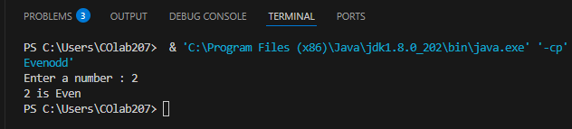

Process related  (5) | Product related  (10) | Total Marks  (25) | Signature

Practical No. 3
Aim : WAP to check switch case using character datatype
Name : Danish Altaf Solkar | Class : CO - B
Enrolment no. : 24111590805 | Batch : 2

Code :-
import java.util.Scanner;
public class SwitchCharacter
{
public static void main(String args[])
{
Scanner scanner = new Scanner(System.in);
System.out.println("Enter a character : ");
char ch = scanner.next().charAt(0);
switch(ch)
{
case'a':
case'A':
System.out.println("You entered 'A' ");
break;
case'b':
case'B':
System.out.println("You entered 'B' ");
break;
default:
System.out.println("You entered an unknown character");
}
}
}

OUTPUT :- 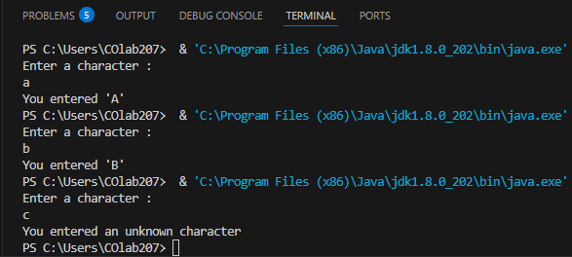

Process related  (15) | Product related  (10) | Total Marks  (25) | Signature

Practical No. 3
Aim : WAP to print 1 to 20 numbers using for,while and do-while loop.
Name : Danish Altaf Solkar | Class : CO - B
Enrolment no. : 24111590805 | Batch : 2
Code :-
class For
{
public static void main(String[] args)
{
System.out.println("Using for loop: ");
for(int i=1;i<=20;i++)
{
System.out.println(i);
}
}
}

OUTPUT :-
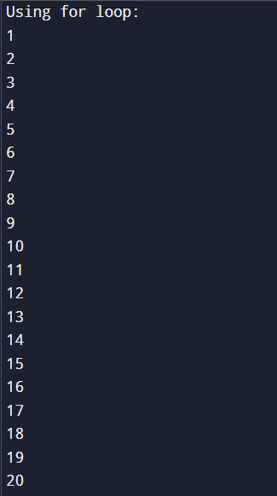

Code :-
class While
{
public static void main(String[] args)
{
int i=1;
System.out.println("Using while loop: ");
while(i<=20)
{
System.out.println(i);
i++;
}
}
}
OUTPUT :-
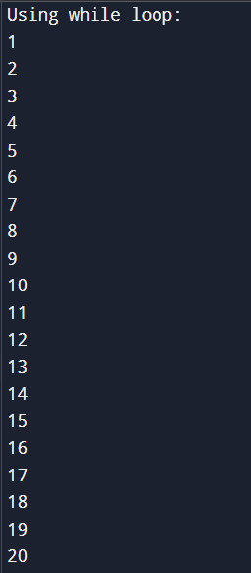

Code :-
class Do_while
{
public static void main(String[] args)
{
int i=1;
System.out.println("Using do-while loop: ");
do
{
System.out.println(i);
i++;
}while(i<=20);
}
}
OUTPUT :-
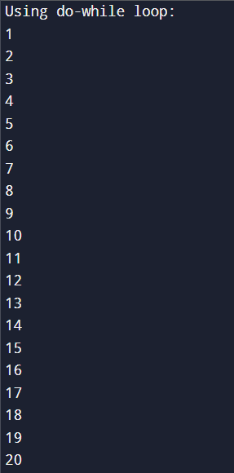
Process related  (15) | Product related  (10) | Total Marks  (25) | Signature

